Application Storyboards

# Application Description

This application will be an interactive display featuring charts and figures derived from data about market shares among New Zealand electrical providers, as made available by the New Zealand government (see <https://www.emi.ea.govt.nz/Retail/Datasets/MarketStructure>). The application will be built using version 3.9 of Python, primarily using PySimpleGUI for its display requirements.

The application will have a live display, featuring a chatroom for discussion and analytical purposes – and will therefore be built to support multi-user access. Data sources relevant to the application will be remotely hosted to allow for concurrent viewing and access by all users. It will also have login and registration – with user account data also stored remotely.

The functional purpose of the application will be to view trends in the market share of New Zealand electrical providers over the recorded time period of 2003-2019 for analytical and business applications.

# Storyboards

## Storyboard One – Login

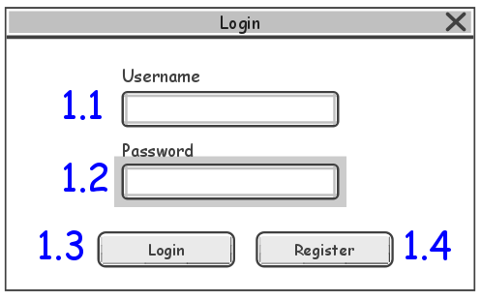

Storyboard One depicts the Login display where users will enter their credentials to enter the main section of the application. It will remain open, but not be interactable while the registration display is open.

|  |  |  |
| --- | --- | --- |
| **Interaction** | **Input** | **Output** |
| 1.1 – Username Text Field | User Text Input | - |
| 1.2 – Password Text Field | User Text Input | - |
| 1.3 – Login Button | User Click | Opens Storyboard 6 – Home (if credentials are valid)  Opens Storyboard 2 (if credentials are invalid) |
| 1.4 – Register Button | User Click | Opens Storyboard 3 – Registration |

## Storyboard Two – Invalid Input Error (Login)

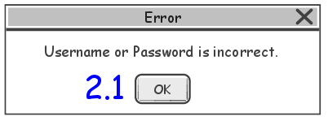

Storyboard Two depicts the error display that will appear if a user attempts to login with invalid credentials. The login display will not be interactable while this display is open.

|  |  |  |
| --- | --- | --- |
| **Interaction** | **Input** | **Output** |
| 2.1 – OK Button | User Click | Returns User to Storyboard 1 – Login |
| Close | User Click | Exits Application |

## Storyboard Three – Registration

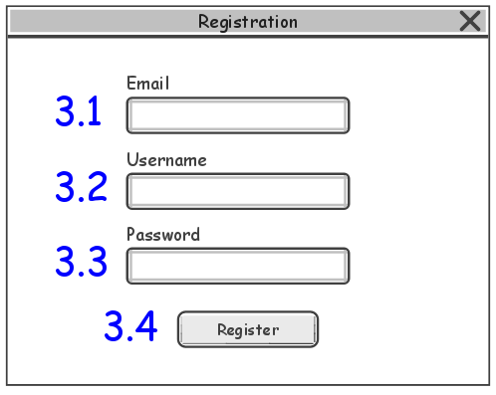

Storyboard Three depicts the Registration display where users will enter their credentials to create a new user account.

|  |  |  |
| --- | --- | --- |
| Interaction | Input | Output |
| 3.1 – Email Text Field | User Text Input | - |
| 3.2 – Username Text Field | User Text Input | - |
| 3.3 – Password Text Field | User Text Input | - |
| 3.4 – Register Button | User Click | Returns User to Storyboard 1 – Login AND  Creates User Account (if credentials are valid)  Opens Storyboard 4 (if Email Text Field input is invalid)  Opens Storyboard 5 (if Username Text Field input is invalid) |
| Close | User Click | Returns User to Storyboard 1 – Login |

## Storyboard Four – Email Taken Error (Registration)

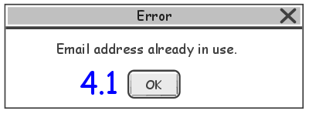

Storyboard Four depicts the error display that will appear if a user attempts to register with an email address that is already attached to an existing user account. The registration display will not be interactable while this display is open.

|  |  |  |
| --- | --- | --- |
| **Interaction** | **Input** | **Output** |
| 2.1 – OK Button | User Click | Returns User to Storyboard 1 – Login |
| Close | User Click | Returns User to Storyboard 1 – Login |

## Storyboard Five – Username Taken Error (Registration)

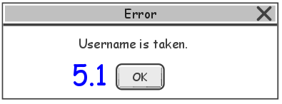

Storyboard Five depicts the error display that will appear if a user attempts to register with a username that is already attached to an existing user account. The registration display will not be interactable while this display is open.

|  |  |  |
| --- | --- | --- |
| **Interaction** | **Input** | **Output** |
| 2.1 – OK Button | User Click | Returns User to Storyboard 3 – Registration |
| Close | User Click | Returns User to Storyboard 3 – Registration |

## Storyboard Six – Home

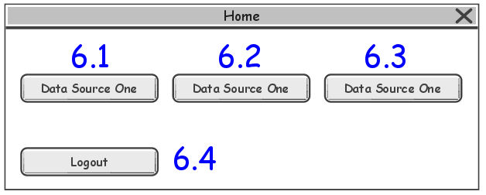

Storyboard Six depicts the home display that will appear after a user successfully logs in. It can be used to navigate to a selected data source display or to exit the application. It will remain open, but not be interactable while a data source display is open.

|  |  |  |
| --- | --- | --- |
| **Interaction** | **Input** | **Output** |
| 6.1 – Data Source One Button | User Click | Opens Storyboard 7 – Data Source (Data Source One) AND  Loads existing figure (if exists) |
| 6.2 – Data Source Two Button | User Click | Opens Storyboard 7 – Data Source (Data Source Two) AND  Loads existing figure (if exists) |
| 6.3 – Data Source Three Button | User Click | Opens Storyboard 7 – Data Source (Data Source Three) AND  Loads existing figure (if exists) |
| 6.4 – Logout Button | User Click | Exits Application |
| Close | User Click | Exits Application |

## Storyboard Seven – Data Source

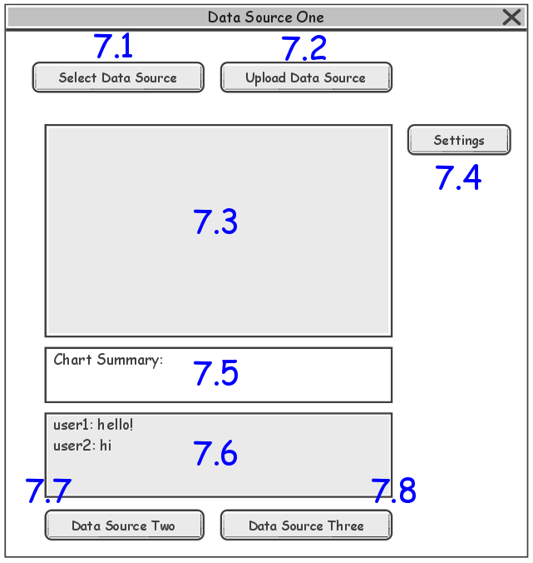

Storyboard Seven depicts the data source display for data source one – displays for data source two and three will be the same functionally, but will have different titles and navigation options. The data source that feeds into the chart display will be able to be manipulated with the top buttons – allowing users to upload and select different data sets. Charts will be able to be interacted with per the limitations of matplotlib figures within the graphical infrastructure of a PySimpleGUI layout. The chart summary displays simple metadata for the current figure/chart. Finally, the live chat will have a session sensitive history and be scrollable (each DES will have its own chatroom).

|  |  |  |
| --- | --- | --- |
| **Interaction** | **Input** | **Output** |
| 7.1 – Select Data Source | User Click | Changes current figure |
| 7.2 – Upload Data Source | User Click | Makes new data source available to select |
| 7.3 – Chart | Matplotlib Controls | Data rendered as matplotlib figure |
| 7.4 – Chart Settings | Dropdown Selection | Configures current figure settings |
| 7.5 – Chart Summary | - | Current figure metadata |
| 7.6 – Chatroom | User Text Input | Current session’s chat history |
| 7.7 – Navigation Option One | User Click | Closes current data source and open new display for selected data source. |
| 7.8 – Navigation Option Two | User Click | Closes current data source and open new display for selected data source. |
| Close | User Click | Returns User to Storyboard 6 – Home |

## Storyboard Eight – Figure Display Error (Data Source)

Storyboard Eight depicts the error display that will appear if a user attempts to display a data source that cannot be parsed by the application. The data source display will not be interactable while this display is open.

|  |  |  |
| --- | --- | --- |
| **Interaction** | **Input** | **Output** |
| 2.1 – OK Button | User Click | Returns User to Storyboard 7 – Data Source |